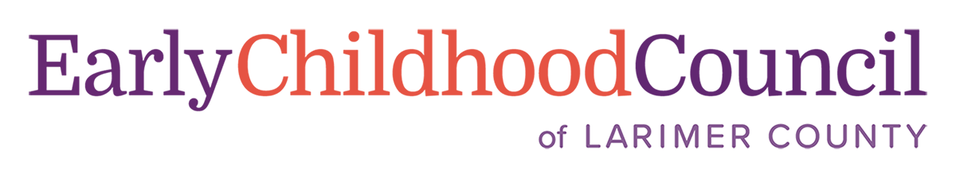

Donation Station Application for the Clothing Swap and School Supply Drive
Thank you for your interest in being a Donation Station for the Clothing Swap and School Supply Drive. We are trying to keep the school supplies and clothing donations separate so that it is easier to pick up, sort, and distribute. Please indicate in the form below how you would like to help. Please contact Danielle at dhastings@ecclc.org or 303-898-4066 with any questions! THANK YOU!

Your Name (First, Last, Preferred Pronouns):
Name of your business or organization:
Physical Address (Include city and zip code):
Hours for Donation Drop-Offs:
Your email:
Your phone number (office and cell please):
Our team will come and pick up the donations as your box is filled, we are planning on Wednesdays and Fridays, but can come other times if your box is getting full. Please contact Danielle at dhastings@ecclc.org or 303-898-4066 if you need an unscheduled pickup. Do you agree to notify ECCLC if your donation box is full? Yes_____________ No_________________
I understand that the donations received at my location are for the Clothing Swap and School Supply Drive and will not be used by my organization or business. Yes_____________ No_________________

